Irresistible Learning Pete Moorhouse

WOOWORK IN EARLY YEARS EDUCATION CPD

Handouts: https://irresistible-learning.co.uk/resources/
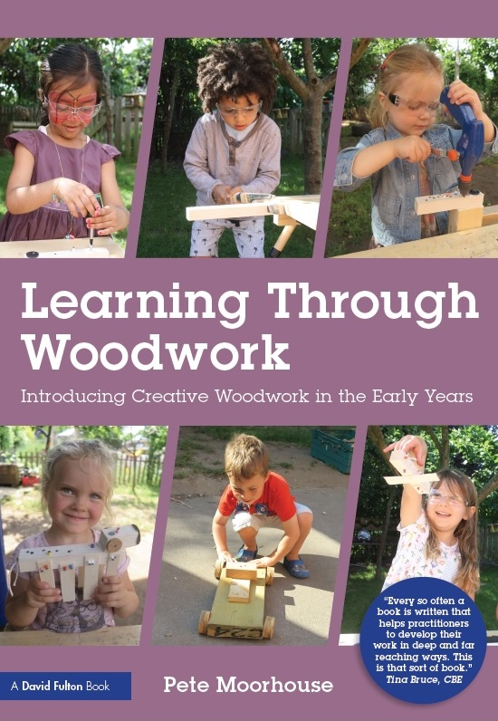
- 20 woodwork top tips for early years
- Book: Learning Through Woodwork by Pete Moorhouse
- Woodwork booklist
- Girl Power (Tools) Booklist!
- Froebel and the Occupation of Woodwork
- Example letter to parents
- Woodwork video instruction of tools
- Woodwork and EYFS
- Woodwork and mathematical thinking
- Woodwork Equipment *
- Health, Safety and Risk guidance
- Woodwork safety glasses
- Gallery of creative woodwork
- Woodwork example risk assessment form *
- Woodwork Health and Safety Checklist *
- Woodwork – Learning outcomes
- Gallery of example woodwork areas
- Woodwork booklet by Pete Moorhouse – Published by Community Playthings
- Learning and Development – mind map * (best to print A3) * useful to print

Learning through woodwork, Pete Moorhouse, Routledge 2018
UK https://www.amazon.co.uk/s?k=pete+moorhouse&i=stripbooks&ref=nb_sb_noss_1
USA https://www.amazon.com/s?k=pete+moorhouse&ref=nb_sb_noss

Big Bang Research Project survey
https://irresistible-learning.co.uk/woodwork/the-big-bang-research-project/

CPD/INSET : https://irresistible-learning.co.uk/training/

Early Childhood Woodwork Association https://earlychildhoodwoodwork.org/

Pete Moorhouse: studio@petemoorhouse.co.uk

