Welcome to the Faculty of Engineering & Construction

The resources in this pack will help prepare you to start your course in September and give you an understanding of some of the techniques and skills you will need to be successful as a student.

Please bring this work to your tutor along with anything else you have created to enrolment; we would love to see what you have done and look forward to meeting you.

Your pack is broken down into 3 tasks. These have been designed to give you an insight into the topics covered within your chosen field.

Each task has several steps to follow to complete it. The processes of researching and preparing your work are essential skills in becoming successful in Construction or Building & Engineering services.

TASK ONE

Your task is to research each trade listed below and describe the jobs that they would undertake in the industry in the box opposite.

Construction
Carpentry & Joinery

Painting & Decorating

Plastering

Brickwork

Civil Engineering

Building & Engineering Services
Plumbing

Electrical

TASK TWO

Health and Safety is taken very seriously across the industry

Everybody has to wear Personal Protective Equipment (P.P.E.)

Using research methods, can you name the items PPE from the images below? What are they used for when working on site?

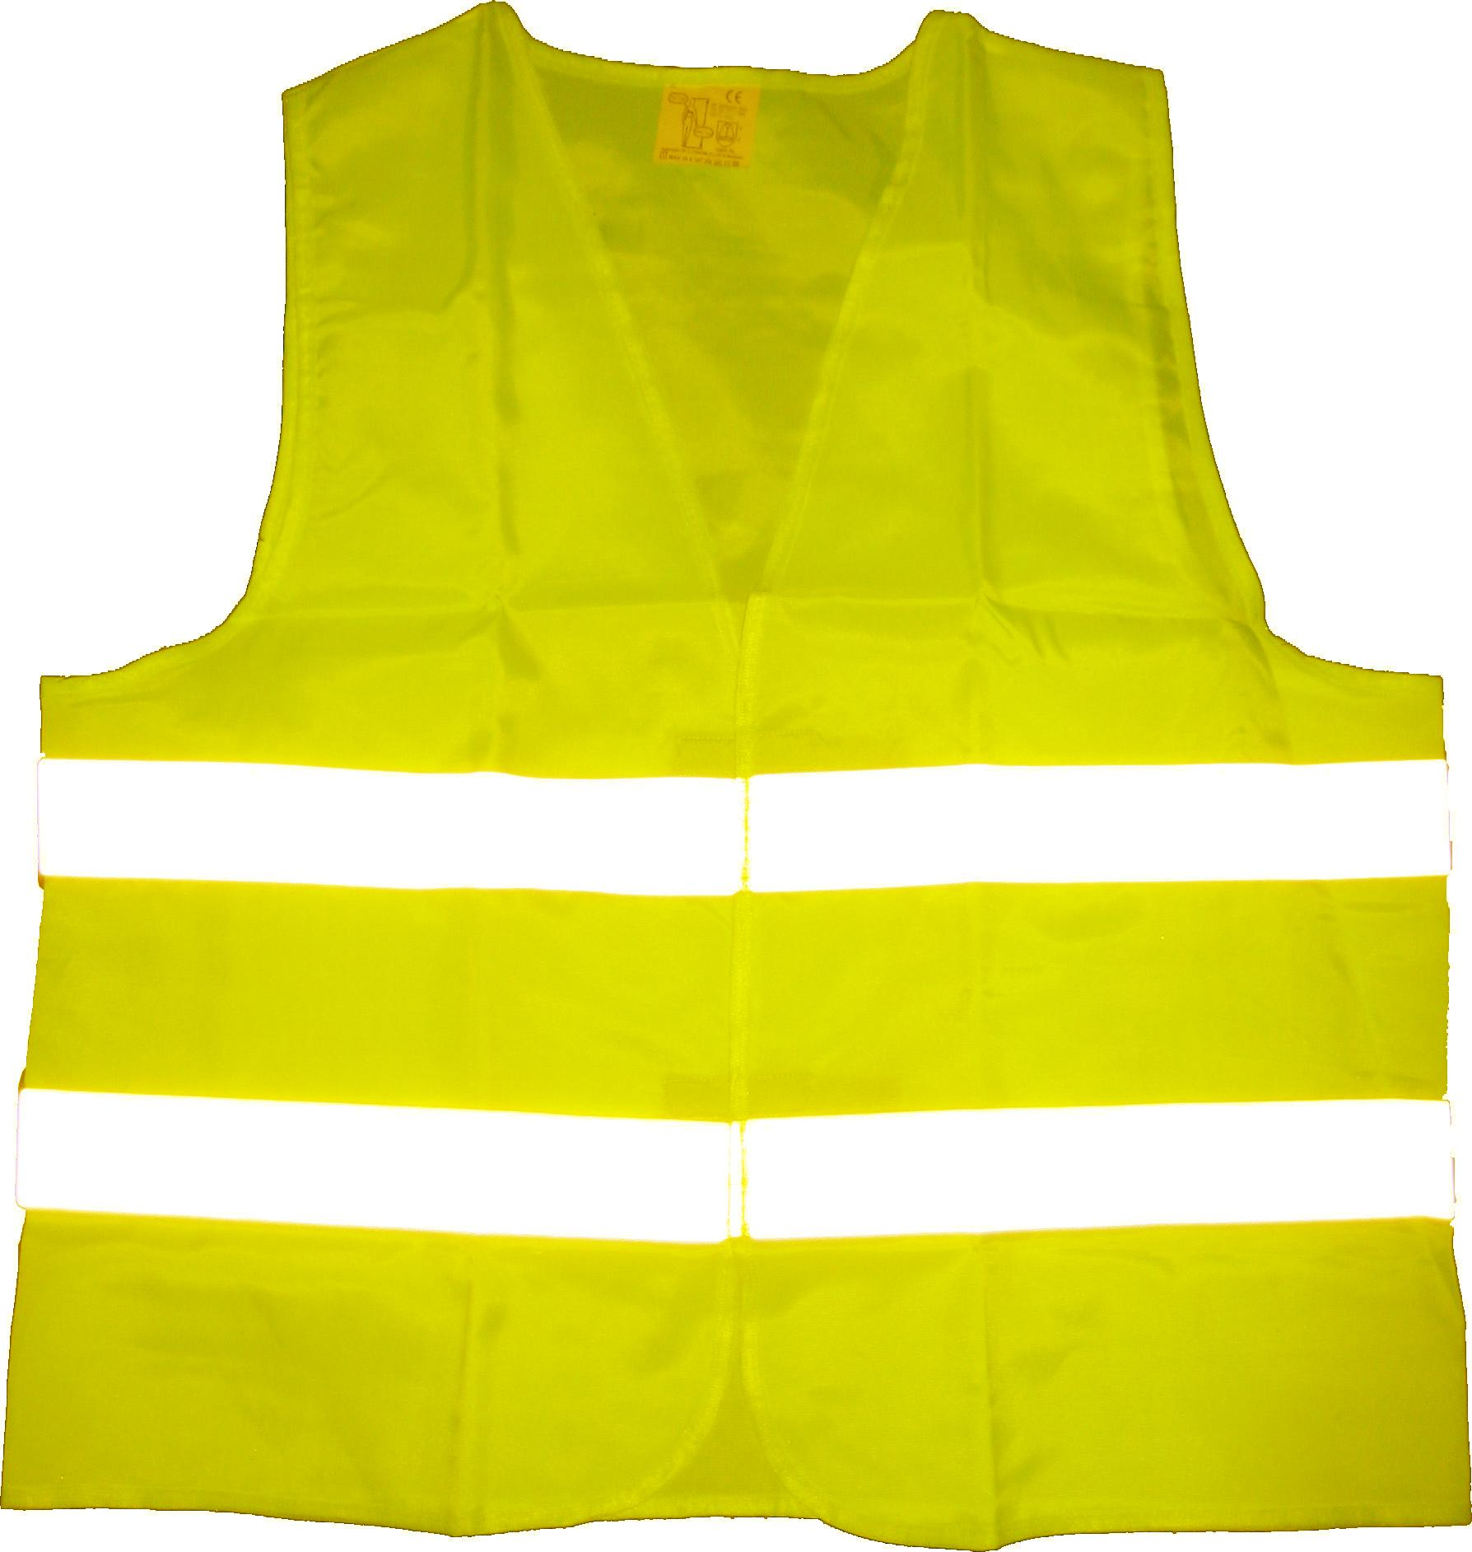
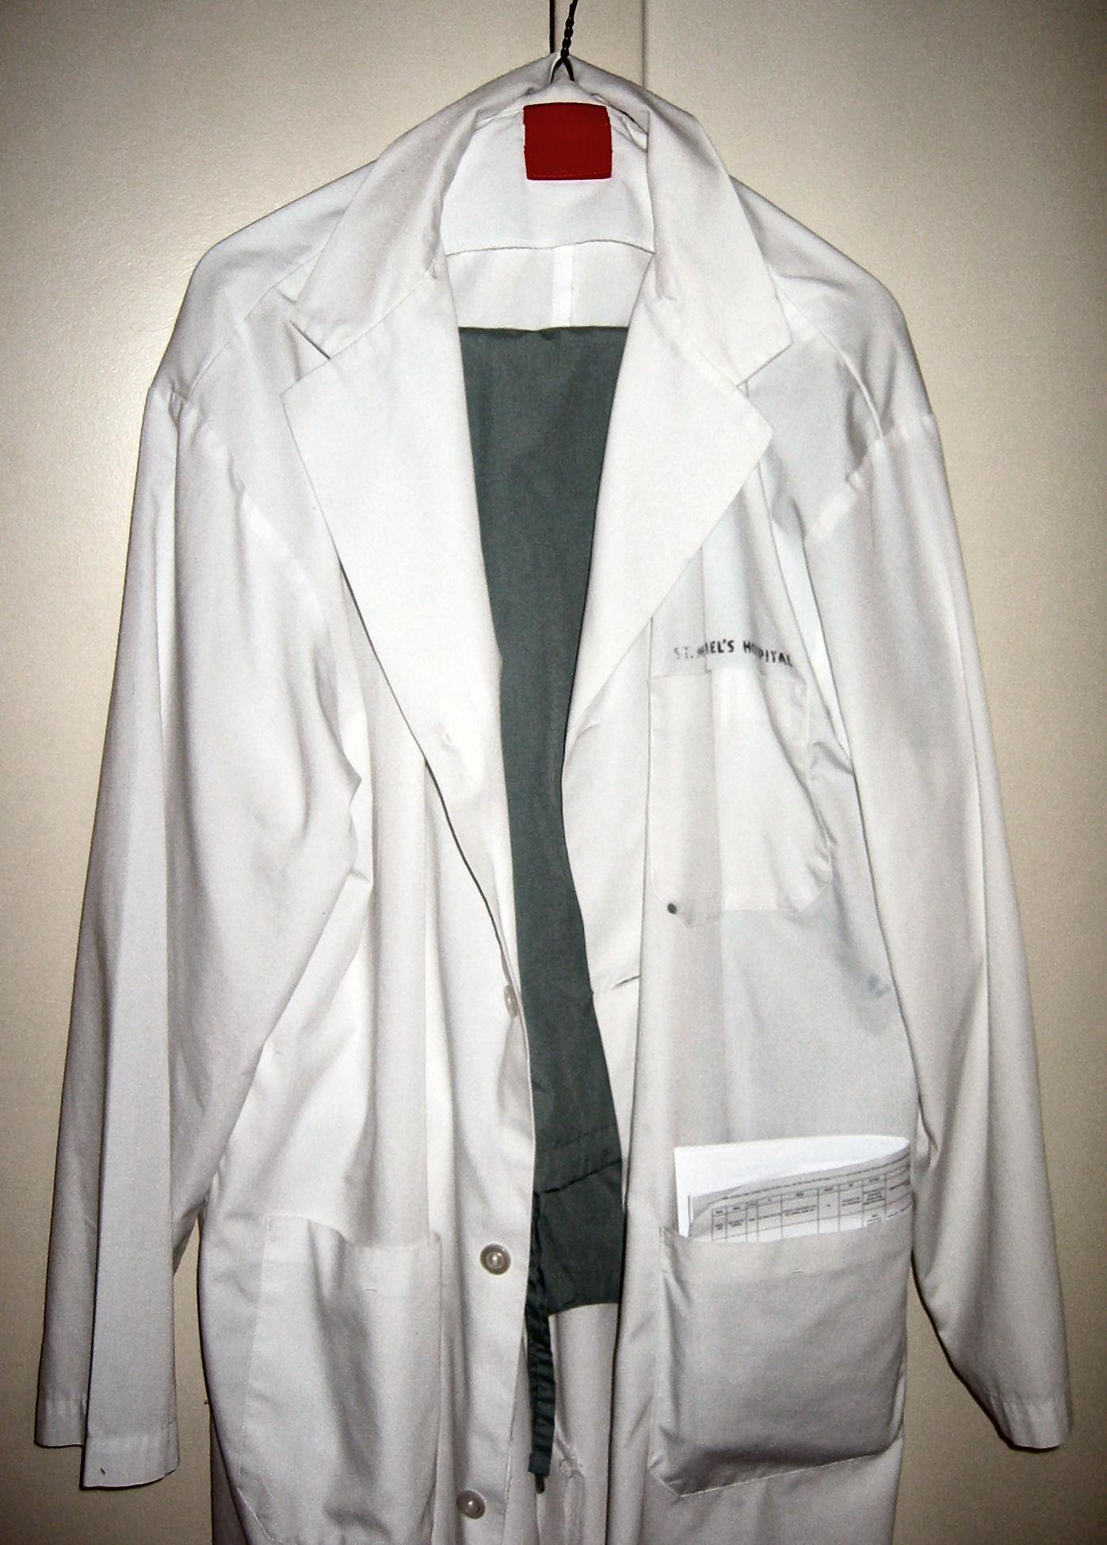
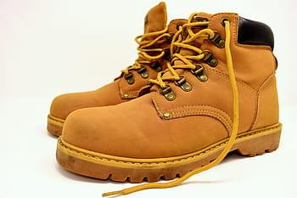
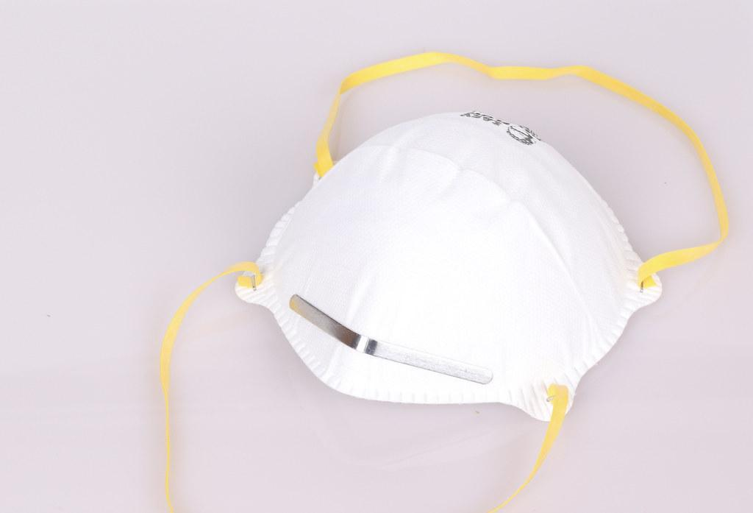
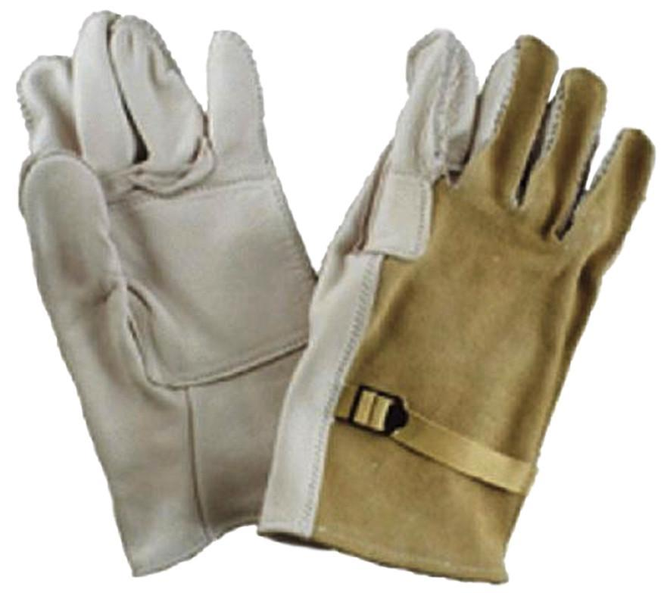
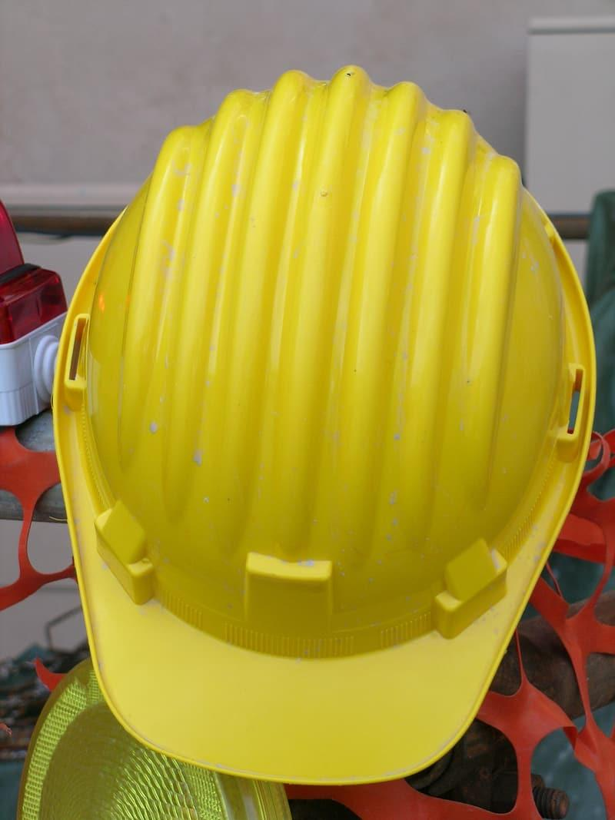

TASK THREE

The list below shows abbreviated legislation.

Your task is to research what the abbreviated legislation stands for and what it covers.

P.U.W.E.R.

C.O.S.H.H.

H.A.S.A.W.A.

R.I.D.D.O.R.

