Initial Assessment Assignment for students progressing to the Level 2 Full Time Engineering course.

STUDENT NAME ______________________________________

All tasks must be attempted by the student. The student MUST write the task number and

print their name on any additional pieces of paper used.

Please record the time taken to complete these three tasks ( ____________ minutes).

Equipment needed - Pencil, rule, compass, calculator (optional), A4 Card

Candidate signature Date

Tutor/assessor signature Date

Initial Assessment Assignment - L2 Engineering

TASKS

Task 1

To work safely in Engineering, we must be able to identify the different types of safety signs and their meanings. Using the internet, library or text books complete the following table:-

SIGN | TYPE | MEANING
 |  | Safety Gloves must be worn
 | Prohibition
 |  | Warning
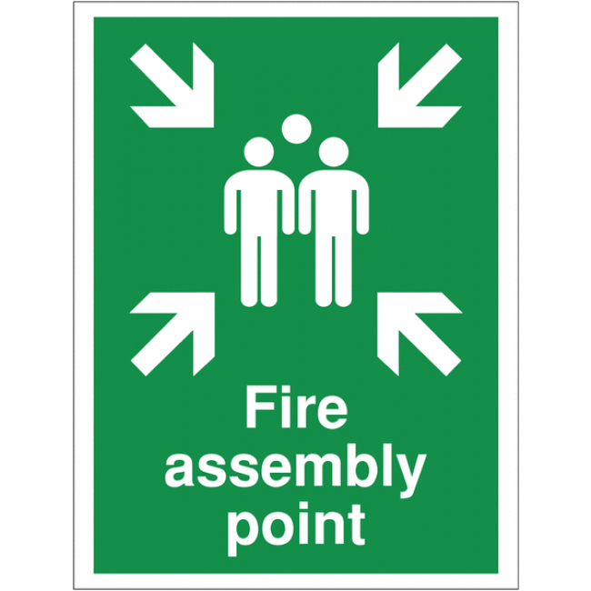 |  | Fire assembly point

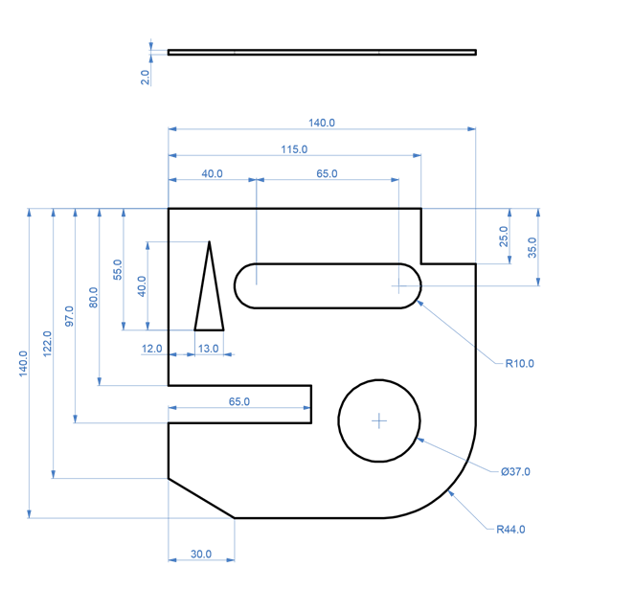
Task 2

Using the dimensions on this drawing, draw out this shape on a piece of card to scale (the same dimensions). Position the drawing in the centre of the piece of A4 card.

Task 3

You have been asked by the welding shop manager to paint one workshop wall with three coats of black ‘ anti glare’ paint. The wall measures 10.5M long and is 3.5M high. On the first tin you read a statement that says “This tin will cover approximately 20M²”.

How many tins of paint will you need to complete this job?

If each tin costs £35.50 and the supplier is offering a 5% discount for students, how much will you spend?

