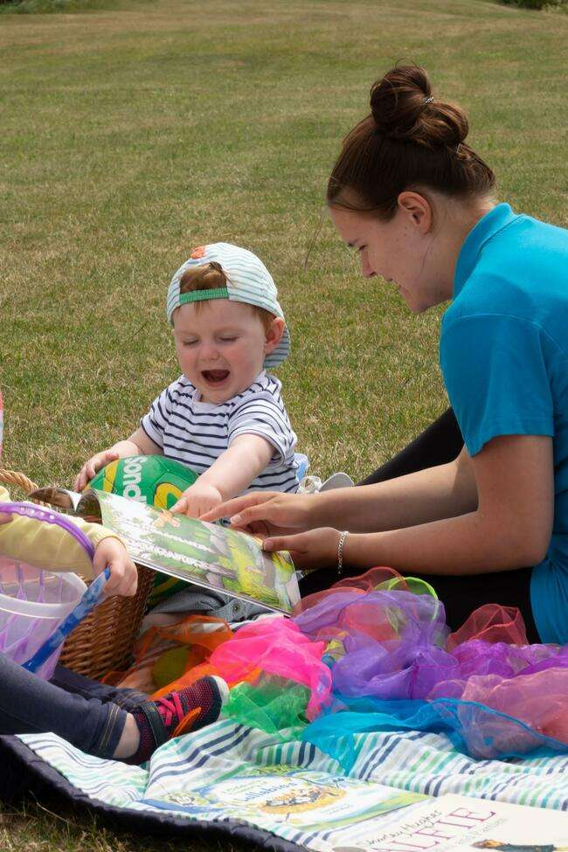
Welcome to GCFE Childcare & Early Years

WELCOME TO YOUR PRE-COURSE ACTIVITY LEARNING BOOKLET FOR CHILDCARE
As part of your transition into college life in which your learning takes a curve into a specialist subject area, the team at Guernsey College of Further Education would like to introduce you to our childcare courses that we offer. In doing so, this booklet invites you to take part in a pre-learning activity that encourages prospective early years educators to consider how you can engage young children in learning activities.
This booklet provides some key information about the college and professions that you might wish to think about as you consider choosing childcare for your further learning.
As a pre-activity, this booklet presents classic stories such as The 3 Little Pigs. Take some time to read a story and familiarise yourself with the sequence of events. After you have read a story, there are prompts to help you consider how you could create some interesting play and craft activities that are based on that story.
Play is an important part of child development because it enables children to explore freely and interpret the world in which they live through social and independent learning experiences. Keeping this in mind, when you create activities for young children it is therefore important that they are engaging so that their development is supported in all areas.
We hope you enjoy this practical booklet and look forward to seeing your ideas and creations upon enrolment onto one of our childcare courses here at Guernsey College of Further Education.

Meet the Early Years team:
Offering young children the opportunity to explore a rich range of creative experiences will help to develop a child who is able to:
• Make connections with others by ‘speaking’ feelings in verbal/non-verbal ways.
• Express thoughts and possibilities on a given subject.
• Challenge ideas and problem solve in a variety of situations.
• Develop a personal definition of aesthetic beauty.
• Consider cultural issues.
• Demonstrate good self-esteem.
• Extend physical skills.
These are life skills that will enable young children not only to access all areas of learning but to develop their full potential as human beings.

As part of your early years course, you will be expected to create resources and activities which you can take with you into early years settings. These resources will be activities which you can use with the children to develop your skills and understanding.

Activity Resource Platforms:

- Pinterest
https://about.pinterest.com/en
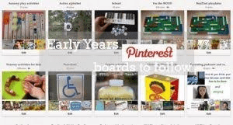
- Nursery World
https://www.nurseryworld.co.uk/

- Early Learning HQ
https://www.earlylearninghq.org.uk/

There are many more, find your favourites and keep a record of them for future practice!
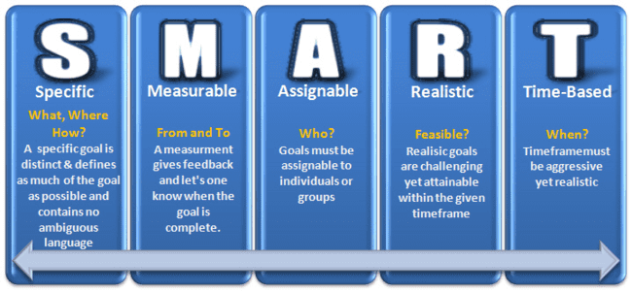
ACTIVITY - SMART Targets
As part of the course, you will be expected to set and review independent targets related to your work. These targets should be S.M.A.R.T. (see above). Can you set yourself a weekly target whilst completing this booklet? Think about what you are trying to achieve? How will you know when it is complete? What do you need to do to complete it? How long will this task take you? Are you able to complete the whole task in the time allocated to the specifications you identified?
ACTIVITY - Story or fairy tale
Choose either a story or a well known fairy tale, I have used the example of the ‘3 Little Pigs’, use the link below to read a free online version of the book; https://www.storyjumper.com/book/read/10213432/THE-THREE-LITTLE-PIGS

The first little pig, built his house made of straw. The second little pig, built his house from sticks. The third little pig built his house from bricks.
What resources could you use to recreate this story with pre-school children aged 4-5 years? You could create the houses using arts and crafts materials or you could act it out indoors or outdoors using props. How might you do this with a small group of preschool children? Share your ideas for whatever story you have chosen below, ensuring they are engaging.
......................................................................................................................................................
......................................................................................................................................................
.................................................................................................................................................
......................................................................................................................................................
......................................................................................................................................................
.................................................................................................................................................
......................................................................................................................................................
......................................................................................................................................................
.................................................................................................................................................
......................................................................................................................................................
......................................................................................................................................................
.................................................................................................................................................
......................................................................................................................................................
......................................................................................................................................................
.................................................................................................................................................
......................................................................................................................................................
......................................................................................................................................................
......................................................................................................................................................
......................................................................................................................................................
......................................................................................................................................................
...........................................................................................................................................

Take some time now to use your own creativity and make something from your story book. What you make should consider the children and their abilities to participate. Bring this with you at enrolment and show your teachers.
Images and resources:

CONSIDERING A CAREER IN CHILDCARE?
Employment opportunities for after you finish your qualifications include;
• Assistant in Day Nurseries or Children’s Centre
• Early Years Teacher
• Early Years Educator
• Childminder
• Nanny
• Nursery Nurse (Local Authority employed or private day care setting)
• Nursery Manager or Deputy Nursery Manager
• Manager or Deputy Manager in Associated Services (Assessment Centre or Contact Services)
• Playworker in Hospitals
• Residential Childcare Worker
• Registered residential Childcare Manager, Deputy or Assistant Manager
• Pastoral Support Worker
• Educational Psychologist
Social Care Pathways include;
• Community Care Officer
• Professional Assistant in Social Care
• Family Centre Worker
• Foster Carer
• Learning Mentor

ACTIVITY - Careers 1
Research 2 prospective careers that you may wish to learn more about. You may select 2 from the list and use the guidance below to obtain clear information about them.
Career;
.....................................................................................................................................................
Average salary;
.....................................................................................................................................................
Average hours worked per week;
.................................................................................................................................................
What qualifications are needed to do this job?
...............................................................................................................
...............................................................................................................
...............................................................................................................
...............................................................................................................
............................................................
What skills are required to do this job?
...............................................................................................................
...............................................................................................................
...............................................................................................................
...............................................................................................................
............................................................
What knowledge is needed to do this job?
...............................................................................................................
...............................................................................................................
...............................................................................................................
.........................................................
What qualities are needed to do this job?
...............................................................................................................
...............................................................................................................
...............................................................................................................
...............................................................................................................
.........................................................
ACTIVITY - Careers 2
Research 2 prospective careers that you may wish to learn more about. You may select 2 from the list and use the guidance below to obtain clear information about them.
Career;
.....................................................................................................................................................
Average salary;
...........................................................................................................................................
Average hours worked per week;
............................................................................................................
What qualifications are needed to do this job?
............................................................................................................................................................................................................................................................................................................................................................................................................................................................
............................................................
What skills are required to do this job?
............................................................................................................................................................................................................................................................................................................................................................................................................................................................
.........................................................
What knowledge is needed to do this job?
...............................................................................................................................................................................................................................................................................................................................................................................................................................................................
What qualities are needed to do this job?
............................................................................................................................................................................................................................................................................................................................................................................................................................................................

ACTIVITY - Celebrating Equality and Diversity
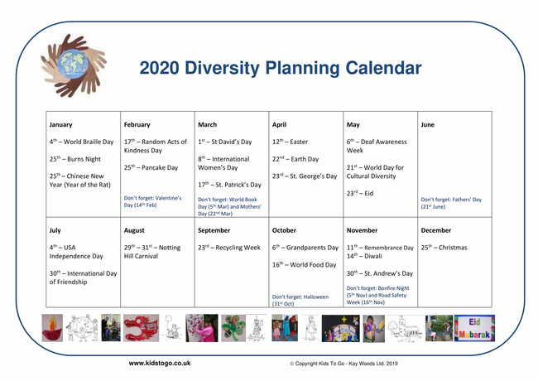
Throughout your Early Years qualifications we will be looking at embedding many different multicultural festivals and celebrations into our learning, as this is essential when working with children. Focusing on diversity, can you find out more about a specific festival or celebration and create a resource which you could take into settings in the future, for example, you could pick Liberation Day, Diwali, Chinese New Year or Australia Day. Below is a list of some examples of festivals.
CRAFT ACTIVITIES WITH CHILDREN AND YOUNG PEOPLE
We tend to think of crafts as something that is recreational and what we do for fun. While crafts are fun, they also offer enormous benefits to children and young people (and adults)!
Can you list 5 benefits which you think children will gain from completing craft activities.

- .

ACTIVITY - Nursery Rhymes
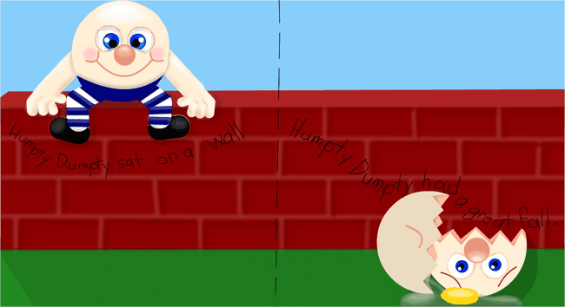

How well do you know nursery rhymes? We would like you to look into nursery rhymes so that you have learnt some off by heart. Once you have done that we would like you to design an A4 poster or picture of any nursery rhyme.Add pictures and images, make it bright and colourful and make sure you have it written out in full.

Once completed, can you make a resource to go alongside the nursery rhyme? It could be a mask, a puppet, a felt board, a story sack….use your creativity to make something amazing!!!

And finally…
We recognise that your hard work needs to be acknowledged. We invite you to bring in the resources you have made and information you have collected during your first week of term (induction week).

We look forward to seeing you at the start of the next academic year.

If you have any additional questions about your course, please contact our Programme Lead, Paula Grady via email, PaulaG@gcfe.net.

