Guernsey College of Further Education

Business Studies

Transition Resources

GUERNSEY COLLEGE OF FURTHER EDUCATION
STUDY PACK
BUSINESS

Match the business owner to their business
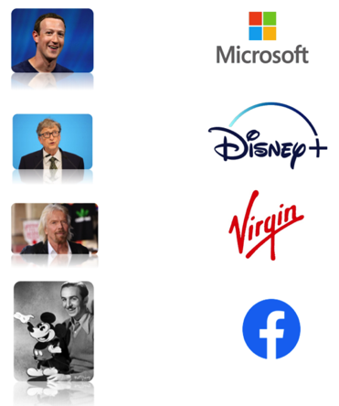
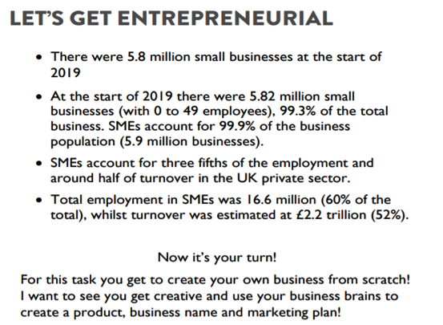

This link is a great step by step guide on how people create their own business:
https://www.thebalancesmb.com/starting-a-small-business-41641

What is your business called? | What does your business sell/offer (service)

All successful Businesses have a logo, not it’s time to make yours!

Who will buy it?
If you are going to be successful in business, you need to choose a target market to aim your product/service at, for example if I am Adidas and am looking to sell the next Yeezy trainer, it is unlikely my target market is over 30.

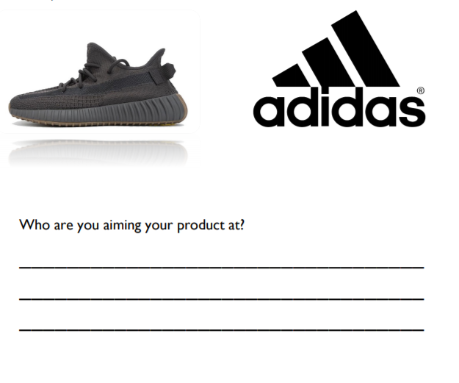
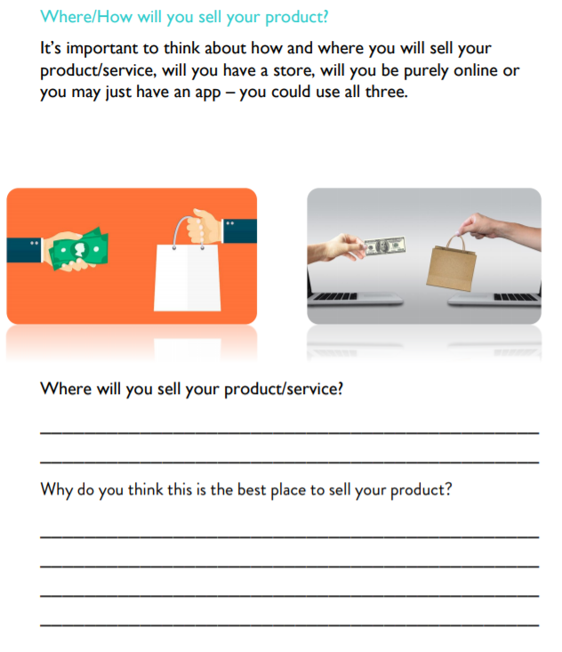

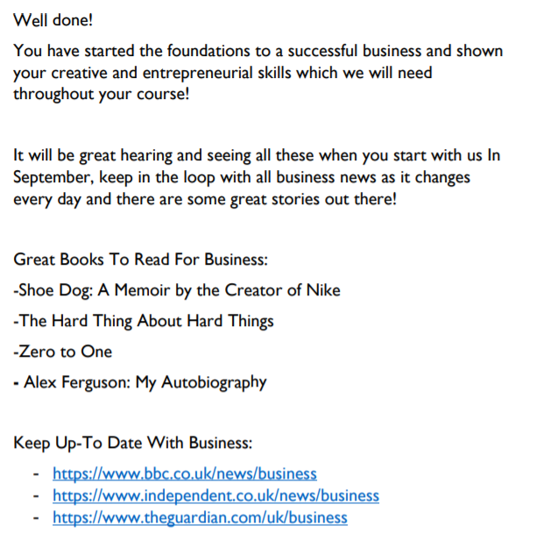

What you have to do for your summer research...

In this project you need to investigate a business organisation. Try to use what contacts you already have. Where do your parents or other relatives work? Find out as much as you can about the business.

It would be great if perhaps you could go to work with your parent/s or relatives for a day, so that you can find out a lot about the business first hand.

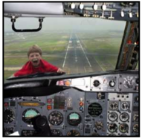
Some occupations may be a little more hazardous than others for you to spend a day with your parents!

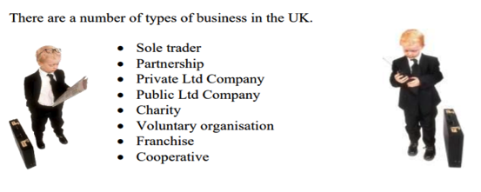

On pages 7-12 there are some questions that you should try to answer for your business.
What you need to research:-
- Type of ownership that business has (e.g. sole trader, partnership, ltd, etc)
- Purpose of the business (e.g. survival, profit, gain market share)
- The advantages and disadvantages for the owner of having that type of business ownership
- Details of type of liability
- Size of the business (e.g. small, small-medium, medium, large)
- Scale of the business (local, regional, national, European, global)
- The main functional areas of the business (e.e.g Marketing, Finance)
- Whether the business is in the Primary, Secondary or Tertiary Sector
- Whether the business has experienced growth or decline over the past few years and why this is so.

Before you start your research though, it would be useful to read the information on pages 4 to 6, which provides you with some basic knowledge of the key topics you will be looking at.
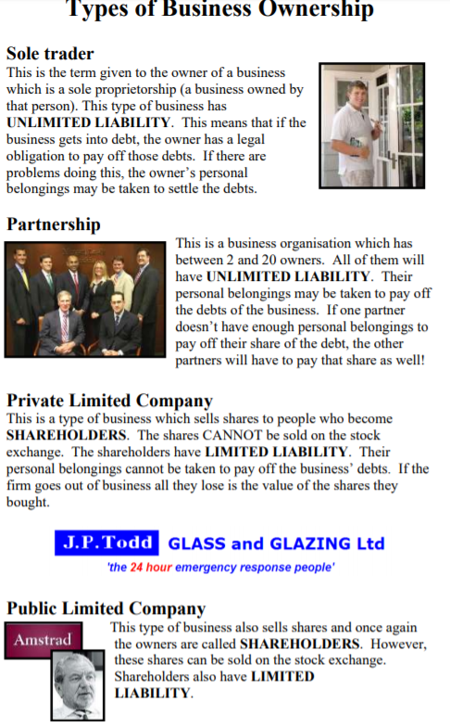
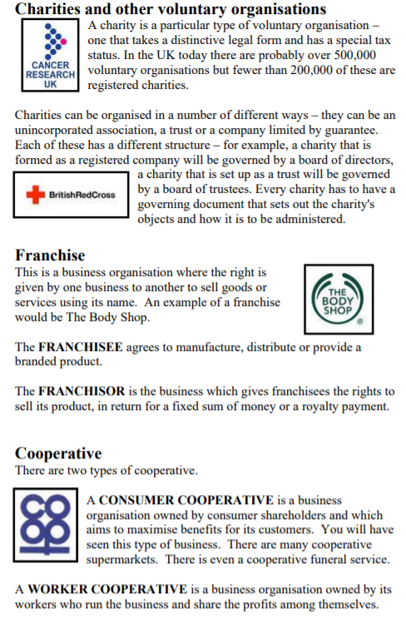

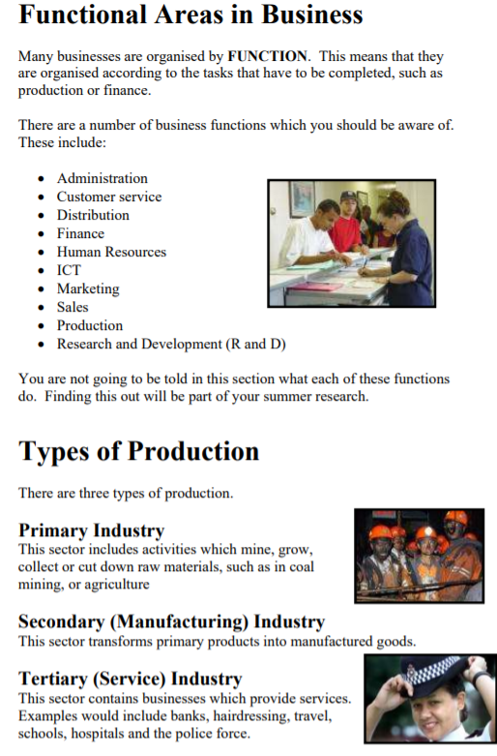
Research for Business

Name of Business

___________________________________________________________________

Location of Business

___________________________________________________________________
Type of ownership this business has e.g. sole trader, partnership, ltd, etc.

___________________________________________________________________

Purpose of the business e.g survival, profit, gain market share:
___________________________________________________________________

___________________________________________________________________

___________________________________________________________________

___________________________________________________________________

___________________________________________________________________

The advantages for the owner having that type of business ownership:
___________________________________________________________________

___________________________________________________________________

___________________________________________________________________

___________________________________________________________________

___________________________________________________________________

The disadvantages for the owner of having that type of business ownership
___________________________________________________________________

___________________________________________________________________

___________________________________________________________________

___________________________________________________________________

___________________________________________________________________

Does the business have limited or unlimited liability?

___________________________________________________________________

___________________________________________________________________

___________________________________________________________________

What does this mean for the business?
___________________________________________________________________

___________________________________________________________________

___________________________________________________________________

Size of the business (e.g. small, small-medium, medium, large)
___________________________________________________________________

___________________________________________________________________

___________________________________________________________________

Scale of the business (local regional, national, European, global)
___________________________________________________________________

___________________________________________________________________

___________________________________________________________________

Which of the following functional areas does the business have? Try to find out as much as you can about each functional area that exists in your business

Administration

___________________________________________________________________

___________________________________________________________________

___________________________________________________________________
Customer Service
___________________________________________________________________

___________________________________________________________________

___________________________________________________________________
Distribution
___________________________________________________________________

___________________________________________________________________

___________________________________________________________________
Finance
___________________________________________________________________

___________________________________________________________________

___________________________________________________________________

Human Resources

___________________________________________________________________

___________________________________________________________________

___________________________________________________________________

ICT
___________________________________________________________________

___________________________________________________________________

___________________________________________________________________
Marketing
___________________________________________________________________

___________________________________________________________________

___________________________________________________________________
Sales
___________________________________________________________________

___________________________________________________________________

___________________________________________________________________
Production
___________________________________________________________________

___________________________________________________________________

___________________________________________________________________
Research and Development (R&D)
___________________________________________________________________

___________________________________________________________________

___________________________________________________________________
Is the business in the Primary, Secondary or Tertiary Sector?

___________________________________________________________________

___________________________________________________________________

___________________________________________________________________
___________________________________________________________________

___________________________________________________________________

___________________________________________________________________

Has the business experienced growth or decline over the past few years, and why is this so?
___________________________________________________________________

___________________________________________________________________

___________________________________________________________________
___________________________________________________________________

___________________________________________________________________

___________________________________________________________________

Making use of what you have discovered
Now DESCRIBE your business. You can produce your evidence in any suitable format. This might include:
- A set of slides and notes for a PowerPoint Presentation
- Posters
- Leaflets
- A written account using a Word Processing Package

Your description of your business must look at :
- Type of ownership that business has (e.g. sole trader, partnership, ltd,etc.)
- Purpose of the business (e.g. survival, profit, gain market share)
- The advantages and disadvantages for the owner of having that type of business ownership
- Details of type of liability
Size of the business (e.g. small, small-medium, medium, large)
- Scale of the business (local, regional, national, European, Global)
- The main functional areas of the business (e.g. Marketing, Finance)
- Whether the business is in the Primary, Secondary or Tertiary Sector
- Whether the business has experienced growth or decline over the past few years and why this is so.

Your work must be handed in to your business tutor at the end of your first lesson in September.

And finally, make sure you do spend lots of time resting and having fun over the summer, there will be lots to do when you join College in September.

