Level 3 Cambridge Technical Certificate in Business
Summer Work

BRING TO YOUR FIRST LESSON

Task One: Key Terms/Definitions (20 minutes)
In your Business course you will use new terminology. These words will become part of your everyday vocabulary and the assessor will be able to credit this knowledge. To get to grips with this terminology it is worth making your own glossary. You could make flashcards to test your knowledge of the new terms. In preparation for September, research the following terms and find appropriate definitions:
Stakeholders (and examples)
- Dividends
- Economies and Diseconomies of Scale (with examples)
- Rationalisation/Retrenchment
- Window Dressing
A useful resource can be found at https://www.tutor2u.net/business/topics

Task Two: Story of a Business (20 minutes)
Some well-known high street businesses were in the national news this year; select ONE from the list below and produce a brief summary outlining a) why they made the news headlines b) causes of their problems c) attempts made to resolve the issues and d) impacts on 2 stakeholder groups.
- Patisserie Valerie
- TopShop
- Debenhams
- You could find a news article by following this link to the BBC News Website
https://www.bbc.co.uk/news/business

Task Three: Using awarding body materials (30 minutes)
There is plenty of useful information for your level 3 Vocational Business course provided by the awarding body - OCR.
https://www.ocr.org.uk/qualifications/cambridge-technicals/business-2016-suite/units/#level-3

If you are studying the one A Level equivalent alongside other subjects select Certificate
If you are studying the 3 A Level equivalent then select Foundation Diploma
Spend some time exploring this website and the specification for information about the course, method of assessment, exam papers, mark schemes and exam reports.
Find out the following: a) How many units are there b) Which units are externally assessed and which units are internally assessed?

EXPLORING BUSINESS

In this unit you will gain an overview of the key ingredients for business success, how businesses are organised, how they communicate, the characteristics of the environment in which they operate, and how this shapes them and their activities. You will also look at the importance of innovation and enterprise to the success and survival of businesses, with the associated risks and benefits.

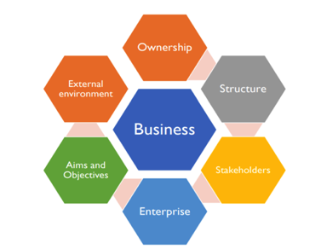

EXPLORING BUSINESS IN THE UK

- There were 58 million small businesses at the start of 2019
- SMEs and the Economy:
- 5.82 million small businesses (with 0 - 49 employees)
- SMEs account for three fifths of the employment and around half of turnover in the UK private sector
- Composition of the business population
- In 2019, there were estimated to be 5.9 million UK private sector businesses
- The UK private sector business population is made up of 3.5 million sole proprietorships (59% for the total), 2.0 million actively trading companies (34%) and 405,000 ordinary partnerships (7%) in 2019

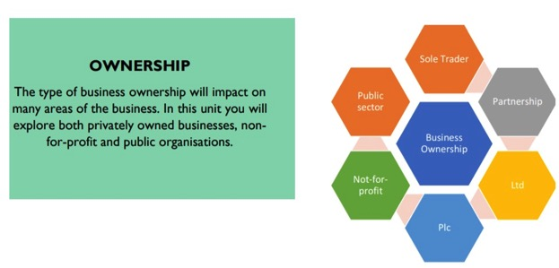

E X P L O R I N G B U S I N E S S - H A V E A GO

Write a definition for each type of business ownership. Consider the facts and examples on the following page and enter each under the correct heading.

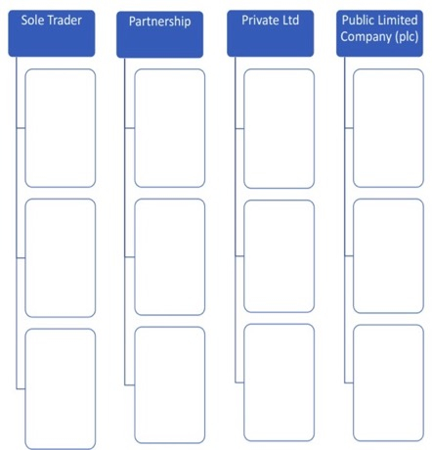

E X P L O R I N G B U S I N E S S - R E S E A R C H

Research the following organisations and write a paragraph detailing the ownership format of each company:-

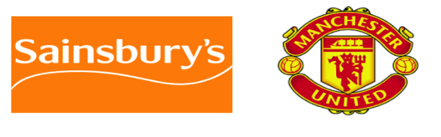

U N I T 2 - D E V E L O P I N G A M A R K E T I N G C A M P A I G N

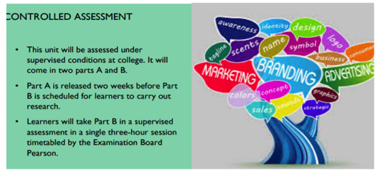

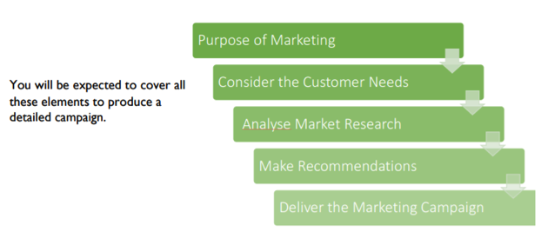

M A R K E T I N G A I M S & O B J E C T I V E S

- Understanding Customer wants & needs
- Developing new products
- Improving profitability
- Increasing market share
- Diversification
- Increased brand awareness & loyalty

- An aim is where the business wants to go in the future, its goals. It is a statement of purpose; we want to grow the business into Europe.

- Business objectives are the stated measurable targets of how to achieve business aims. Reach £15 million sales turnover in Europe over the next year.

- Businesses will have different aims and objectives that they want to achieve.

TASK

Describe the overall Aim of the company

For the following:
- Soft Drink Company
- Charity
- Car Manufacturer

MARKETING CAMPAIGNS

Businesses use Marketing Campaigns to promote their products through different types of media these include:

TASK

- Promotion is a key part of the marketing campaign and you would have to consider who you are iming your advertising at. Also what do you want to communicate - JD Sports young people in the latest summer clothes
- Produce a poster to be placed at a bus stop
- For an Autumn/Winter Campaign for Next PLC
- Consider they sell Women's, Men’s and Children’s clothes as well as Home Furnishing

P E R S O N A L A N D B U S I N E S S F I N A N C E

Personal finance involves the understanding of why money is important and how managing your money can help prevent future financial difficulties

The business finance aspects of the unit introduce you to accounting terminology, the purpose and importance of business accounts and the different sources of finance available to businesses.

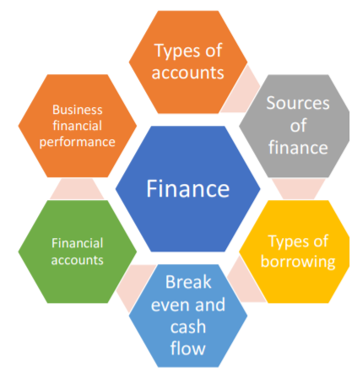

The importance of understanding finance

- 60% of employers expect to see at least a moderate skills shortage in accountancy and finance in 2018.
- 80% of businesses expect their finance teams’ workloads to increase this year
- Demand for financial analysts has increased by 10% in 2018
- Over half of businesses believe Brexit will widen the skills gap in the accounting and finance sector

Different types of Costs:
- Businesses deal with different types of costs; fixed and variable
- Outlining and monitoring these costs assists a business with financial planning, cash flow, break even and analysing profitability and liquidity.

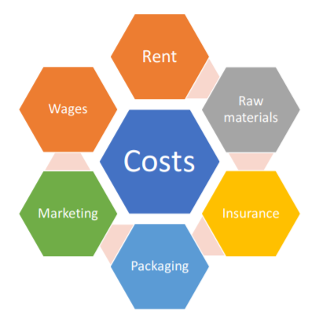
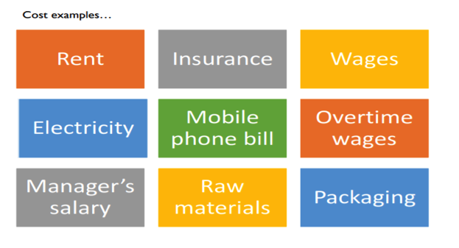

Define each of the 3 types of costs below. Then categorize the examples on the previous page under the correct heading.

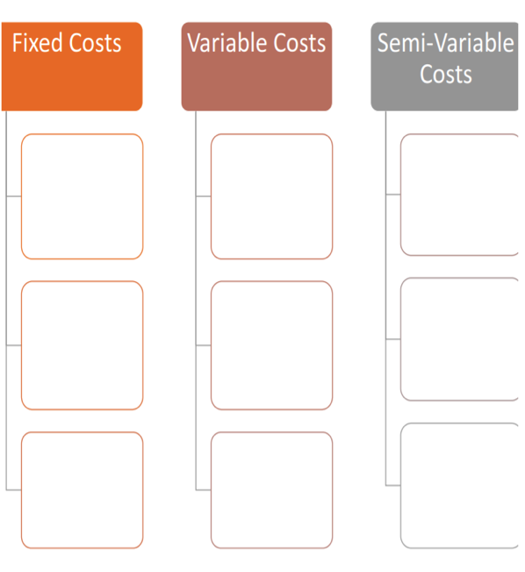

F I N A N C I A L C A S E S T U D Y

Read the following information and suggest the fixed, variable and semi variable costs for the business:

Richer Sounds is a highly successful hi-fi, home cinema and TV retail specialist based in the UK. It sells through its 53 stores and online. It has won several awards for its high level of sales and for its levels of customer service. Trading conditions have been difficult in recent years. The increased use of digital technology in marketing and its impact on the way customers search for information and shop is a serious threat to Richer Sounds’ growth. It faces competition from rivals such as Amazon and Argos who offer a much wider range of products. Richer Sounds’ mission is `Experience Better’. Staff aim to beat its competitors by providing customers with superior:
- Knowledge & expertise
- PRoducts & pricing
- Customer service
The company recruits employees based on their natural friendliness and their passion for its products. Staff are trained regularly to keep them up to date with new products. The company is committed to providing employees with secure, well-paid jobs. Employees receive an excellent salary, good career opportunities and a number of additional benefits. Richer Sounds has a low price strategy. If a customer finds any product cheaper elsewhere for up to seven days after purchase, RIcher Sounds will charge £100 less. To enable it to pursue this approach Richer Sounds has a low price strategy. If a customer finds any product cheaper elsewhere for up to seven days after purchase, Richer Sounds will charge £100 less. To enable it to pursue this approach, Richer Sounds deliberately chooses out of the way locations for its shops; this means its rents are lower than its competitors. It has spent nearly 40 years building relationships with suppliers, meaning it can negotiate lower prices and pass these savings on to customers.

M A N A G I N G A N E V E N T

UK EVENT INDUSTRY FACTS AND STATS

- Events management is one of the most exciting and dynamic sectors of business
- What's the UK industry worth?
- The events sector is worth £42.3 billion to the UK economy in terms of direct spend by event delegates, attendees and organisers, an 8% rise on the previous report. A substantially higher figure is achieved once the wider economic impacts (indirect and induced spend plus accompanying persons’ spend are included. The spend by those accompanying attendees at business events is worth an additional £7.7 billion.

THE VALUE OF BRITAIN’S EVENTS SECTOR - DIRECT SPEND BY SEGMENT

- Conferences and meetings - £19.9 billion
- Exhibitions and trade fairs - £11.0 billion
- Incentive travel and performance improvement £1.2 billion
- Corporate hospitality and corporate events - £1.2 billion
- Outdoor events £1.1 billion
- Festivals and cultural events - £1.1 billion
- Music events £1.3 billion
- Sporting events £2.3 billion

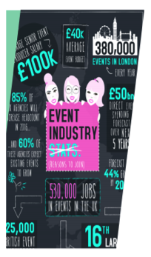 | HOW MANY PEOPLE WORK IN THE UK EVENTS INDUSTRY?  There are over 25,000 businesses in the sector including event organisers, venues, destination marketing organisations (DMOs),  destination management companies (DMCs), exhibition contractors, event production companies, and a whole plethora of suppliers: transport operators, telecommunications and IT companies, interpreters and translators, speciality caterers, event insurance specialists, and many others.  The best estimates are that the sector sustains 570,000 full time equivalent (FTE) jobs, mostly in small and medium sized enterprises (SMEs). The top 10 leading event agencies in the UK have a turnover of more than £3.5 billion, much of which is generated outside the UK.

More than 7,000 major outdoor events are held each year. OUtdoor events cover a breadth of activity from major festivals, agricultural shows, sporting and charity events through to small village and craft events. Following the Olympics in 2012, the UK has established itself as a world leader in outdoor events, with many UK companies exporting their expertise. THe sector has witnessed huge growth; between 2005 and 2009 there was an average annual increase of more than 1.64 million adults attending outdoor events in the UK | 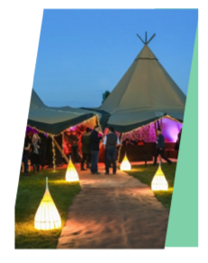
CHARITY EVENTS

Since 2007, the number of fundraising events has increased by 700% and participant numbers have doubled. Event fundraising grew by 8% in 2012 (based on the number of JustGiving fundraising pages created. Running events remain the most popular kind of event, accounting for 77% of all event fundraising pages, however, trekking is the activity which raises the most funds - an average of £885 per event. Fundraising via triathlons grew by 21% between 2011 and 2013, raising an average of £740 per event. Cycling fundraising events have grown the most, up by 30% since 2011 raising an average of £610 per event.
Other types of fundraising events raise on average:
- Parachuting/Skydive £465
- Swimming £395
- Running £360
- Walks £300
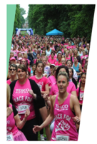

EXHIBITIONS AND TRADE FAIRS

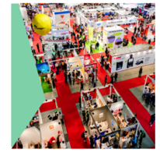 | Exhibitions play a vital role in the UK economy in generating exports. Many exhibitions in the UK have established themselves as a strong base for international trade. UK exhibitions attract over 13 million visitors each year, generating £11.0 billion in spend. In 2010, over 265,000 exhibitors participated in events. 20% from outside the UK. In 2010 exhibitors spent £2.7 billion on goods and services to demonstrate at events.  The sector was worth an estimated £19.2 billion in venue and destination direct spend in 2015
MUSIC FESTIVALS AND CONCERTS
- More than 10.4 million music tourists spent £2.3 billion in 2015. Around 41% of live music audiences are music tourists. Overseas music tourists spend on average £657 each while in the UK. It is estimated that around 24,251 full-time jobs are sustained by music tourism.
- British music events were attended by a staggering 27.7 million people in 2015. With 15% of UK festival-goers spending over £250 while at the event.
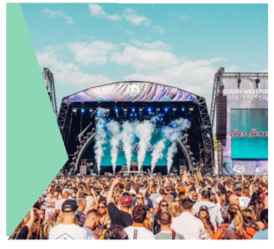

TASK
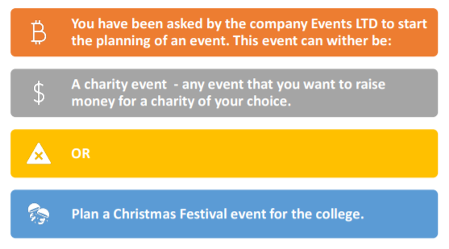

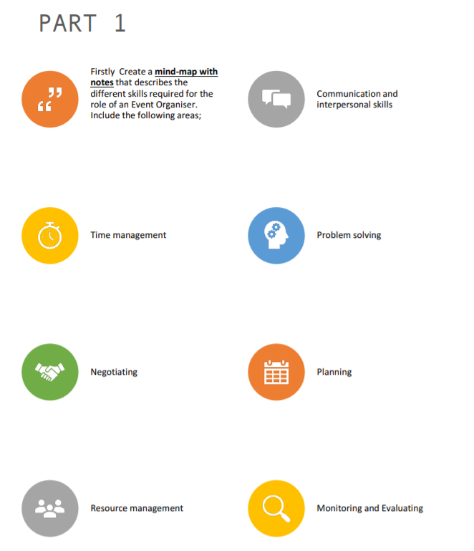

PART 2

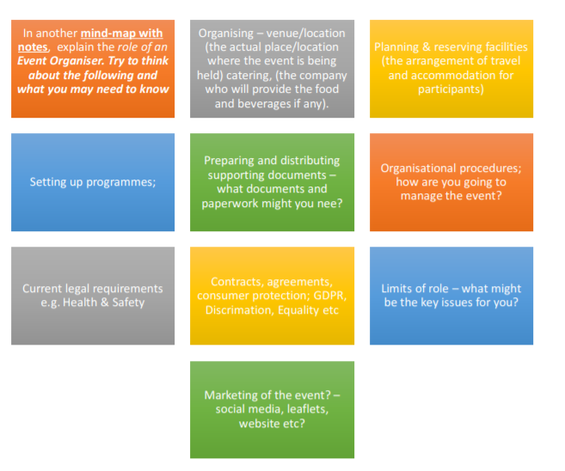

Contact Us:

Email: college@gcfe.net
Facebook: https://www.facebook.com/GuernseyCollege
Twitter: GuernseyCollege@GuernseyCollege
Website: http://www.guernseycollege.ac.gg/

