Study Pack

Sport

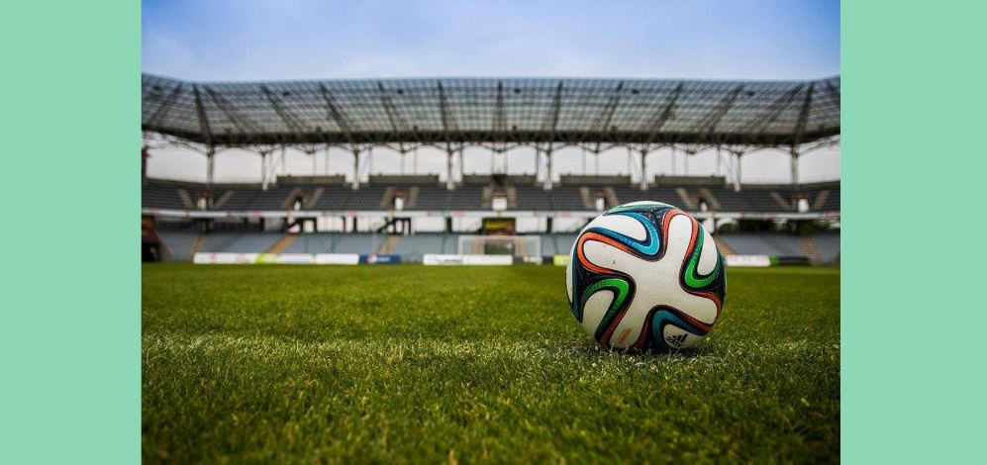

TASKS TO COMPLETE

Task 1
Find a blank image of a skeleton, like this one
(scan the QR code on your phone)

Can you identify the bones listed below and label them on your skeleton?

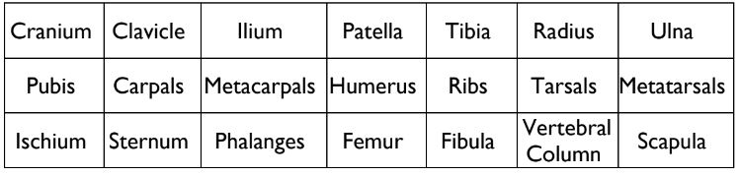

Task 2

- Identify the 6 physical components of fitness and the 5 skill-related components of fitness

- Select an athlete of your choice. Put the components of fitness in order of importance for your chosen athlete, e.g. Simone Biles (gymnast)
1. Flexibility, 2. Speed, 3. Power…

- One physical component of fitness is ‘Body Composition’.
What somatotype would suit your athlete best?

FILMS & DOCUMENTARIES TO WATCH

FILMS YOU COULD WATCH

- The Program: Lance Armstrong Movie on Netflix (Current Issues in Sport)
- Happy Gilmore on Netflix (Practical Individual Sports)
- Coach Carter on Netflix (Sports Leadership)
- Ronaldo on Netflix (Elite Sports Performance)
- Moneyball on Netflix (Sports Leadership)

DOCUMENTARIES YOU COULD WATCH

- Mo Farah and the Salazar Scandal on BBC iPlayer (Current Issues in Sport)
- All or Nothing: Manchester City on Prime Video (Sports Coaching)
- Game Changers on Netflix (Sports Nutrition)
- Sir Alex Ferguson: Secrets of Success (Sports Coaching)
- Barça Dreams on Netflix (Current Issues in Sport)
- Conor McGregor: Notorious on Netflix (Elite Sports Performance)

PREPARATION RESEARCH

INTERNET RESEARCH

Can your choice of running trainers, football boots or training attire really influence your performance? - Is Technology the New Performance Enhancing Drugs? (Huffington Post)

If you have a clear career path in mind, do some research into your next steps after College. Look at the National Careers Service government website to see requirements for different jobs in Sport. Alternatively, you could research what careers there are in the Sports sector, if you’re a little unsure.

RECOMMENDED READING

- Bounce: The Myth of Talent and the Power of Practice - Matthew Syed
- Inverting the Pyramid: The History of Football Tactics - Jonathan Wilson
- Kicking Off: How Women in Sport are Changing the Game - Sarah Shephard
- Achieve the Impossible - Professor Grag Whyte OBE
- Why We Sleep - Matthew Walker

RECOMMENDED WEBSITES

- BBC Sport www.bbc.co.uk/sport
- Sky Sports www.skysports.com
- Guardian Sport www.theguardian.com/profile/guardian-sport
- Bleacher Report www.bleacherreport.com
- TED Talks - Sports www.ted.com
- FourFour Two www.fourfourtwo.com
- Planet Rugby www.planetrugby.com
- London 2012 Highlights www.olympic.org/london-2012
- The Science of Sport Podcast https://play.acast.com/s/realscienceofsport

ONTO THE 18TH HOLE

Let’s get creative, it is important to have the occasional break from your studies. Your challenge is to create your own crazy golf hole!
The rules are simple:

- You must have permission from your parent.guardian to participate
- You should aim to ‘putt’ a soft ball, or table tennis ball, into a cup/saucepan, or similar household object
- This should be done in the most creative way possible
- Tweet your entry to us on Twitter @Eccles1st4Sport

Here is some inspiration for for:
https://www.youtube/watch?v=UYqcusQJ3EU

HOME WORKOUT
CHOOSE 2 EXERCISES FROM EACH COLUMN. PERFORM FOR 45 SECONDS EACH. REST AT THE END OF YOUR ROUND FOR 1 MINUTE. REPEAT CIRCUIT 3 TIMES.

Remember to Stay Active
Research shows that being sedentary is bad for your physical and mental health, so staying active during this difficult time is important. Feel free to use our home workout guide as a method for you to engage in physical activity, or better yet, create your own home workout!

Contact Us:

Email: college@gcfe.net
Facebook: https://www.facebook.com/GuernseyCollege
Twitter: GuernseyCollege@GuernseyCollege
Website: http://www.guernseycollege.ac.gg/

